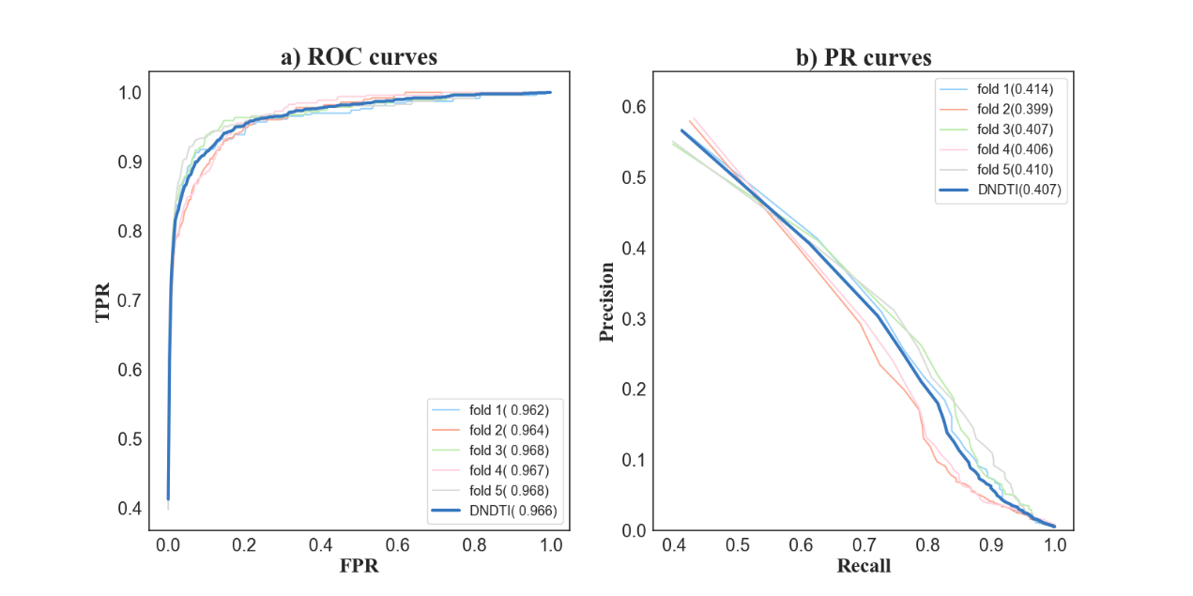

Supplemental Figure 1. ROC and PR curves of DNDTI for each of 5folds.